*Personal*

Trust Equity Index (TEi) Report.



Table of Contents

**Your TEi Report.** **3**

**Demystifying Trust & Impact.** **4**

Why trust? 4

Objective of the Survey 4

What You Get by Doing The Survey 4

Benefits of the Survey 4

Determining the Trust Equity Profile 5

Connection Between Trust and Impact. 5

Research Rigour. 5

**Your Trust Equity Report.** **6**

**TEi Score: 00:00** **6**

**Trust Profile: T-IBCi** **7**

Your Trust Profile Analysis 8

Your Trust Elements Analysis 9

**Impact Profile: I-MECA** **11**

What is an Impact Profile? 11

Your Impact Story: I-MESC (Based on your survey) 11

Impact Profile Analysis 12

Impact Elements Analysis 13

# Your TEi Report.

**Focus.** Personal / Team / Network / Organisation

**Level.** Foundational / Intermediary / Advanced

**Name.** The Dark Sith

Dear [...]

Welcome to your journey with the Personal Trust Equity Index (TEi) Survey. By completing this foundational survey, you join a global community dedicated to mastering trust. This report equips you with essential knowledge and tools to enhance your personal and professional relationships.

How to Read Your Personal Report:

* Familiarise Yourself with Key Concepts: Start with "Demystifying Trust" to understand the principles of impact, trust, and the TEi framework.
* Navigate Your TEi Dashboard: Use your personalised dashboard as a guide through your results.
* Analyse Your Results: Discover insights on how your attributes align with our IBCi and MECA frameworks. This analysis will help you leverage your strengths and identify areas for improvement.

Remember, enhancing trust is a continuous, transformative journey that benefits not only you but also those around you. We hope this report helps you build stronger, trusting relationships and a more impactful presence in all life areas.

Warm regards,

Dominic Wilhelm

Executive Director

The Global Trust Project

| **TEi Score: 00:00**  *A combination of your trust and impact.* | **Trust Profile: T-IBCi**  *A measure of integrity, benevolence, capability and inclination.* | **Impact Profile: I-MECA**  *A measure of your mindfulness, skills, capabilities and arrest.* |
| --- | --- | --- |
| Lorem ipsum dolor sit amet, consectetur adipiscing elit. Vestibulum ante ipsum primis in faucibus orci luctus et ultrices posuere cubilia Curae; Fusce ultricies velit nec velit aliquam. | Integrity and Benevolence are relatively low, while Capabilities and Inclination are developed. This profile suggests a person who trusts and executes well but may struggle with ethical consistency and empathy. | Mindfulness is least developed; effectiveness, skills, and compelling attributes increase progressively. |

# Demystifying Trust & Impact.

## Why trust?

Trust fundamentally transforms interactions and relationships across personal, organisational, and societal levels. It is the cornerstone of effective collaboration, robust leadership, and sustainable growth. Understanding and cultivating trust can lead to more effective engagements and a more cohesive society.

## Objective of the Survey

The Personal Trust Equity Index Survey is designed to assess and enhance your personal trustworthiness and impact within professional contexts. By engaging with this survey, you can better understand your own trust dynamics and learn how to amplify your influence and reliability in the workplace.

## What You Get by Doing The Survey

You will receive practical insights and effective tools that demystify trust, operationalise trustworthiness, and facilitate a higher impact in both your professional and personal life. This includes personalised feedback to help refine and apply trust-building strategies effectively.

## **Benefits of the Survey**

Engaging with the Personal Trust Equity Index Survey empowers you to harness the power of trust, enhancing your effectiveness and leadership capabilities. It provides a detailed, actionable pathway to greater professional success and personal fulfilment.

## Determining the Trust Equity Profile

The survey evaluates you on the Trust Equity Index, which combines Trust and Impact profiles. The Trust Profile assesses your integrity, benevolence, and capabilities, while the Impact Profile evaluates your mindfulness, effectiveness, competency, and your ability to engage compellingly.

**Trust Elements (IBCi)**

* Integrity: Measures your adherence to moral and ethical principles, ensuring consistency in your actions and promises.
* Benevolence: Assesses your willingness to act in the interest of others, fostering relationships and positive interactions.
* Capabilities: Evaluates the skills and competencies necessary for you to perform effectively in various situations.
* Inclination: Considers your natural propensity to trust, influencing how trust is given and received.

**Impact Elements (MECA)**

* Mindful: Focuses on your awareness of the context and implications of your actions, enhancing strategic decision-making.
* Effective: Gauges the success of your actions in achieving desired outcomes, reflecting your ability to execute plans successfully.
* Capable: Looks at your skills and abilities to accomplish tasks, highlighting your proficiency in managing challenges.
* Arresting: Measures your power to captivate and influence others, crucial for leadership and persuasive communication.

## Connection Between Trust and Impact.

Elevating your levels of trust directly enhances your personal influence, boosts organisational performance, and contributes to societal wellbeing. A heightened trust level ensures more impactful interactions across all areas of your life.

## Research Rigour.

The survey is grounded in extensive research and the internationally recognised frameworks developed by TGTP. It provides a robust, scientifically backed approach to understanding and developing trust and impact.

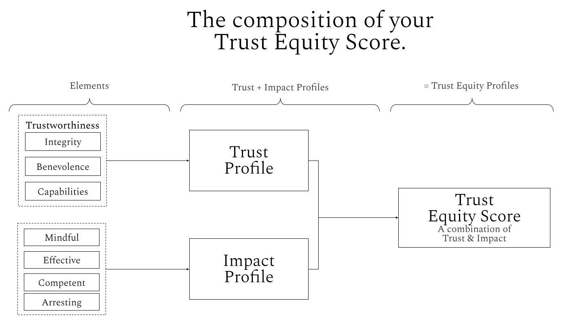

# Your Trust Equity Report.

## TEi Score: 00:00

**Overview** *576 possible combinations of Trust/Impact Profiles.*



Lorem ipsum dolor sit amet, consectetur adipiscing elit. Vestibulum ante ipsum primis in faucibus orci luctus et ultrices posuere cubilia Curae; Fusce ultricies velit nec velit aliquam. Lorem ipsum dolor sit amet, consectetur adipiscing elit. Vestibulum ante ipsum primis in faucibus orci luctus et ultrices posuere cubilia Curae; Fusce ultricies velit nec velit aliquam.

Lorem ipsum dolor sit amet, consectetur adipiscing elit. Vestibulum ante ipsum primis in faucibus orci luctus et ultrices posuere cubilia Curae; Fusce ultricies velit nec velit aliquam. Lorem ipsum dolor sit amet, consectetur adipiscing elit. Vestibulum ante ipsum primis in faucibus orci luctus et ultrices posuere cubilia Curae; Fusce ultricies velit nec velit aliquam.

Lorem ipsum dolor sit amet, consectetur adipiscing elit. Vestibulum ante ipsum primis in faucibus orci luctus et ultrices posuere cubilia Curae; Fusce ultricies velit nec velit aliquam. Lorem ipsum dolor sit amet, consectetur adipiscing elit. Vestibulum ante ipsum primis in faucibus orci luctus et ultrices posuere cubilia Curae; Fusce ultricies velit nec velit aliquam.

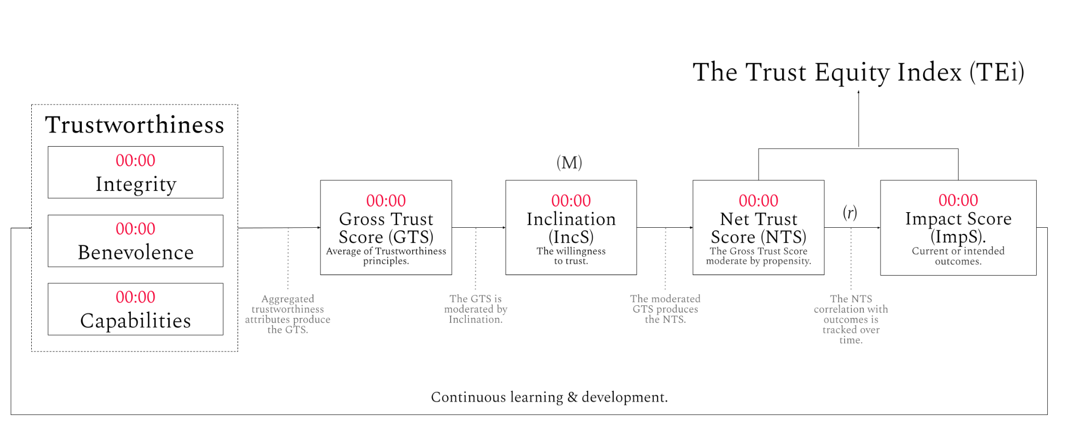

## **Trust Profile: T-IBCi**

Net Trust Score (NTS): 00:00

| **What Is a Trust Profile?** | **Trust Elements** |
| --- | --- |
| Trust Profiles offer a structured approach to understanding and quantifying how individuals are perceived in terms of trustworthiness. Each profile is a unique combination of four key elements—Integrity, Benevolence, Capabilities, and Inclination—that together shape how a person is likely to be trusted by others. Integrity assesses adherence to moral and ethical principles, Benevolence reflects the extent to which a person is perceived to be kind and considerate, Capabilities focus on the skills and competencies a person possesses, and Inclination measures their general propensity to trust others. These profiles help in identifying strengths and areas for improvement, providing a comprehensive view that can be used for personal development and in organisational settings to enhance interpersonal and professional relationships. | * Integrity (I): 00:00 * Benevolence (B): 00:00 * Capabilities (C): 00:00 * Gross trust Score (GTS): 00:00 * Inclination (i): 00:00 * Net Trust Score (NTS): 00:00 |

**Your Trust Profile: T-IBCi**



The T-IBCi profile suggests professionals with strong Capabilities and Inclination, yet with underdeveloped Integrity and Benevolence. This configuration could suit roles valuing technical proficiency but may pose challenges in contexts needing ethical judgement and deep empathy.

Implications: This profile might limit effectiveness in leadership roles, affecting career progression and trust within teams due to potential shortcomings in ethical engagements and relational depth.

Areas for improvement: Consider engaging in ethics training and community service to strengthen moral principles and empathy. Reflecting on decision impacts and seeking diverse feedback could refine their professional approach. Emotional intelligence-focused team-building exercises may also enhance their interpersonal skills.

By addressing these areas, individuals can improve their trustworthiness and effectiveness, thereby fostering stronger relationships and enhancing leadership capabilities within their professional environments.

## **Your Trust Profile Analysis**

| **T-IBCi** | Description | Implications | Practices | Examples |
| --- | --- | --- | --- | --- |
|  | Integrity and Benevolence are relatively low, while Capabilities and Inclination are developed. This profile suggests a person who trusts and executes well but may struggle with ethical consistency and empathy. | Potentially leads to superficial relationships and questionable ethical decisions despite effective task completion. | 1. Daily ethical reflection. 2. Practice empathy by actively listening. 3. Self-assessment on personal growth in benevolence. | * Reflect on one ethical decision made each day. * Listen to a friend's concerns without giving advice, focusing on understanding their feelings. * Write weekly in a journal about interactions and emotional insights. |



## **Your Trust Elements Analysis**

| **Integrity** | Description | Implications | Practices | Examples. |
| --- | --- | --- | --- | --- |
| 0-1 | Shows a fundamental lack of adherence to ethical standards, rarely acts consistently. | Severely affects credibility and trust, limits growth opportunities. | 1. Reflect daily on decisions to align with ethical standards. 2. Commit to transparency in all actions. 3. Regularly review personal goals and ethics. | * Start each day by setting an ethical goal, such as honesty in all communications. * Explain your decision-making process openly in team meetings. * Evaluate your actions at the end of the day to ensure they align with your ethical standards. |
| **Benevolence** | Description | Implications | Practices | Examples. |
| 0-1 | Rarely shows genuine concern for others, acts predominantly out of self-interest. | Significantly hinders the development of supportive and meaningful relationships. | 1. Practise random acts of kindness. 2. Reflect on the impact of your actions on others. 3. Volunteer in community services to enhance empathy. | * Offer to help a colleague with a heavy workload without being asked. * At the end of each day, reflect on how your actions might have affected others. * Spend a weekend a month volunteering at a local food bank. |
| **Capabilities** | Description | Implications | Practices | Examples. |
| 0-1 | Lacks fundamental skills required for their role, significantly undermining effectiveness. | Severely limits reliability and trust, leading to challenges in professional development. | 1. Identify and list essential skills needed for your role. 2. Engage in daily practice to develop these skills. 3. Set small, measurable goals for skill improvement. | * Practise a new software tool each evening. * Ask a mentor to help identify areas for improvement. * Take on a small project that allows you to develop and showcase new skills. |
| **Inclination** | Description | Implications | Practices | Examples. |
| 0-1 | Displays deep-seated distrust or severe reluctance to trust, often rooted in past negative experiences. | Significantly hampers all forms of interpersonal interactions and trust-building efforts. | 1. 1. Reflect on past experiences to understand the roots of distrust. 2. Engage in small group activities to slowly build trust. 3. Keep a journal to document trust-building experiences and feelings. | * 1. Write about a past trust breach and how it made you feel, then discuss this with a therapist or trusted friend. 2. Join a book club or small interest group to practise trusting in a safe environment. 3. Note any positive or negative trust interactions daily to identify patterns and progress. |

## **Impact Profile: I-MECA**

Impact Score (ImS): 00:00

Impact Profile: 00:00

| **What is an Impact Profile?** | **Impact Elements** |
| --- | --- |
| Impact Profiles evaluate the effectiveness of individuals in their environments, based on how they apply their personal and interpersonal skills to achieve desired outcomes. Each profile is defined through a combination of four critical components—Mindfulness, Effectiveness, Skills, and Compelling nature. Mindfulness relates to self-awareness and presence, Effectiveness measures the ability to achieve goals, Skills denote the practical abilities a person has, and Compelling describes their ability to influence and inspire others. These profiles are crucial for understanding how individuals impact their surroundings, guiding development in career paths, leadership roles, and personal growth by highlighting how their actions and interactions drive results and create lasting impressions. | * Mindful: 00:00 * Effective: 00:00 * Competent: 00:00 * Compelling: 00:00 |

## **Your Impact Story: I-MESC** (Based on your survey)



The I-MESC profile highlights individuals with strong Mindfulness and Effectiveness, supported by lesser Skills and Compelling attributes. This profile suits roles requiring strategic awareness and operational efficiency but may face challenges in technically demanding tasks or influential leadership positions.

Implications: This configuration might limit the individual's effectiveness in roles that demand high technical proficiency or strong persuasive abilities, potentially affecting their leadership capabilities.

Areas for improvement: Enhancing Skills through targeted professional training and boosting their Compelling nature by developing persuasive communication techniques can balance their profile. Participating in advanced technical courses and public speaking workshops are recommended.

These strategies aim to complement their strategic mindfulness and operational effectiveness with robust technical skills and enhanced influence, broadening their professional impact.

## **Impact Profile Analysis**

| **I-MESC** | **Description** | **Implications** | **Practice** | **Examples** |
| --- | --- | --- | --- | --- |
|  | Mindfulness is least developed; effectiveness, skills, and compelling attributes increase progressively. | May struggle to fully engage stakeholders due to a lack of awareness, despite strong communication skills. | 1. Start each day with a mindful reflection on personal goals. 2. Practise effective communication in daily interactions. 3. Use compelling storytelling in casual conversations. | * Reflect each morning on how personal actions align with long-term objectives. * Focus on clear and concise language in emails and meetings. * Share personal stories that resonate with friends or colleagues. |



## **Impact Elements Analysis**

| **Mindfulness** | Description | Implications | Practices | Examples. |
| --- | --- | --- | --- | --- |
| 0-1 | Shows an almost complete lack of awareness and presence in personal interactions and decision-making. | Severely limits ability to effectively engage or respond to others, undermining trust and cooperation. | 1. Practise mindful breathing for a few minutes each day to increase presence. 2. Engage in active listening during all conversations. 3. Reflect on daily experiences to develop self-awareness. | * Start each day with five minutes of focused breathing. * During conversations, concentrate solely on understanding the other person without planning your response. * End each day by writing down key interactions and your responses to them. |
| **Effective** | Description | Implications | Practices | Examples. |
| 0-1 | Demonstrates a fundamental lack of achieving desired outcomes; efforts rarely lead to successful results. | Severely impedes professional credibility and the ability to progress in personal and career goals. | 1. Identify key areas where effectiveness can be improved. 2. Set small, achievable objectives to build a track record of success. 3. Reflect on daily activities to identify what is and isn't working. | * Choose one small task each day and focus on completing it successfully. * Break larger projects into manageable parts and celebrate small victories. * Keep a daily log of tasks and outcomes to evaluate effectiveness. |
| **Skills** | Description | Implications | Practices | Examples. |
| 0-1 | Lacks the basic skills necessary for effective performance in their role. | Severely undermines professional competence and trustworthiness. | 1. Identify key skills lacking and seek resources to learn the basics. 2. Practise these skills through daily tasks. 3. Seek feedback from peers to gauge improvement. | * Start with free online tutorials to learn essential software used in your field. * Apply these skills in low-stakes projects at work. * Ask for constructive criticism from a trusted colleague weekly. |
| **Compelling** | Description | Implications | Practices | Examples. |
| 0-1 | Lacks the ability to engage or influence others effectively; communications often fail to resonate or inspire. | Impacts ability to lead or motivate, potentially stalling career progression and team dynamics. | 1. Practise basic communication skills, such as public speaking or writing. 2. Observe and emulate compelling figures in your industry. 3. Seek feedback on your communication styles and adjust based on responses. | * Join a local Toastmasters club to improve public speaking. * Watch TED Talks to study effective communication. * Ask for detailed feedback after presentations or meetings to refine your approach. |

**Closing thoughts.**

Lorem ipsum dolor sit amet, consectetur adipiscing elit. Vestibulum ante ipsum primis in faucibus orci luctus et ultrices posuere cubilia Curae; Fusce ultricies velit nec velit aliquam. Lorem ipsum dolor sit amet, consectetur adipiscing elit. Vestibulum ante ipsum primis in faucibus orci luctus et ultrices posuere cubilia Curae; Fusce ultricies velit nec velit aliquam.

Lorem ipsum dolor sit amet, consectetur adipiscing elit. Vestibulum ante ipsum primis in faucibus orci luctus et ultrices posuere cubilia Curae; Fusce ultricies velit nec velit aliquam. Lorem ipsum dolor sit amet, consectetur adipiscing elit. Vestibulum ante ipsum primis in faucibus orci luctus et ultrices posuere cubilia Curae; Fusce ultricies velit nec velit aliquam.

Lorem ipsum dolor sit amet, consectetur adipiscing elit. Vestibulum ante ipsum primis in faucibus orci luctus et ultrices posuere cubilia Curae; Fusce ultricies velit nec velit aliquam. Lorem ipsum dolor sit amet, consectetur adipiscing elit. Vestibulum ante ipsum primis in faucibus orci luctus et ultrices posuere cubilia Curae; Fusce ultricies velit nec velit aliquam.